**Nama : Dicky Wahyu Pratama**

**Asal : Universitas Trunojoyo Madura**

**Grup : Grup 2**

**“Tugas 2”**

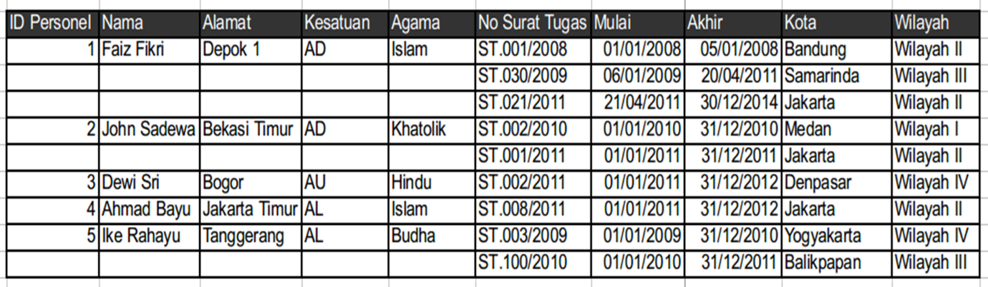

Ubah table berikut menjadi 1 NF dan 2 NF

Jawaban :

* 1 NF Normalisasi

|  |  |  |  |  |  |  |  |  |  |
| --- | --- | --- | --- | --- | --- | --- | --- | --- | --- |
| ID Personal | Nama | Alamat | Kesatuan | Agama | No Surat Tugas | Mulai | Akhir | Kota | Wilayah |
| 1 | Faiz Fikri | Depok 1 | AD | Islam | ST.001/2008 | 01/01/2008 | 05/01/2008 | Bandung | Wilayah II |
| 1 | Faiz Fikri | Depok 2 | AD | Islam | ST.030/2009 | 06/01/2009 | 20/04/2011 | Samarinda | Wilayah III |
| 1 | Faiz Fikri | Depok 3 | AD | Islam | ST.021/2011 | 21/04/2011 | 30/12/2014 | Jakarta | Wilayah II |
| 2 | John Sadewa | Bekasi timur | AD | Khatolik | ST.002/2010 | 01/01/2010 | 31/12/2010 | Medan | Wilayah I |
| 2 | John Sadewa | Bekasi timur | AD | Khatolik | ST.001/2011 | 01/01/2011 | 31/12/2011 | Jakarta | Wilayah II |
| 3 | Dewi Sri | Bogor | AU | Hindu | ST.002/2011 | 01/01/2011 | 31/12/2012 | Denpasar | Wilayah IV |
| 4 | Ahmad Bayu | Jkarta timur | AL | Islam | ST.008/2011 | 01/01/2011 | 31/12/2012 | Jakarta | Wilayah II |
| 5 | Ike Rahayu | Tanggerang | AL | Budha | ST.003/2009 | 01/01/2009 | 31/12/2010 | Yogyakarta | Wilayah IV |
| 5 | Ike Rahayu | Tanggerang | AL | Budha | ST.100/2010 | 01/01/2010 | 31/12/2011 | Balikpapan | Wilayah III |

* 2 NF

1. Personal Data

|  |  |  |  |  |
| --- | --- | --- | --- | --- |
| ID Personal | Nama | Alamat | Kesatuan | Agama |
| 1 | Faiz Fikri | Depok 1 | AD | Islam |
| 2 | John Sadewa | Bekasi timur | AD | Katolik |
| 3 | Dewi Sri | Bogor | AU | Hindu |
| 4 | Ahmad Bayu | Jakarta timur | AL | Islam |
| 5 | Ike Rahayu | Tangerang | AL | Budha |

1. Data Tugas

|  |  |  |  |  |  |
| --- | --- | --- | --- | --- | --- |
| No Surat Tugas | ID Personal | Mulai | Akhir | Kota | Wilayah |
| ST.001/2008 | 1 | 01/01/2008 | 05/01/2008 | Bandung | Wilayah II |
| ST.030/2009 | 1 | 06/01/2009 | 20/04/2011 | Samarinda | Wilayah III |
| ST.021/2011 | 1 | 21/04/2011 | 30/12/2014 | Jakarta | Wilayah II |
| ST.002/2010 | 2 | 01/01/2010 | 31/12/2010 | Medan | Wilayah I |
| ST.001/2011 | 2 | 01/01/2011 | 31/12/2011 | Jakarta | Wilayah II |
| ST.002/2011 | 3 | 01/01/2011 | 31/12/2012 | Denpasar | Wilayah IV |
| ST.008/2011 | 4 | 01/01/2011 | 31/12/2012 | Jakarta | Wilayah II |
| ST.003/2009 | 5 | 01/01/2009 | 31/12/2010 | Yogyakarta | Wilayah IV |
| ST.100/2010 | 5 | 01/01/2010 | 31/12/2011 | Balikpapan | Wilayah III |